**Setup Ethereum NFT Market place with Moralis**

Software Requirement

* GitHub

<https://github.com/>

* Ethereum Nft marketplace boilerplate

<https://github.com/jonghojoon/ethereum-nft-marketplace-boilerplate>

* Yarn

<https://yarnpkg.com/cli/install>

* Node

<https://nodejs.org/en/>

* Moralis

<https://moralis.io/>

* Remix – Online Ethereum IDE: Solidity compiler and deploy <https://remix.ethereum.org/#optimize=false&runs=200&evmVersion=null&version=soljson-v0.8.7+commit.e28d00a7.js>
* Metamask: a crypto wallet & gateway to blockchain apps

<https://metamask.io/>

* Ethereum public test networks: Ropsten, Rinkeby, Goerli, & Sepolia

*Note: Testnet shutdown timeline. Ropsten by Q4 2022. Rinkeby 02/03 2023.

Brand new Goerli & Sepolia will be replaced. <https://blog.ethereum.org/2022/06/21/testnet-deprecation>

* Ropsten testnet faucet (still active)

<https://faucet.egorfine.com/>

* Goerli Authenticated Faucet: Get Free ether

<https://goerli-faucet.mudit.blog/>

* Visual Studio Code: Editor for any source code

<https://code.visualstudio.com/>

Installation Procedure

1. Go to the GitHub to clone Ethereum-nft-marketplace-boilerplate source code to your directory in PC.
2. GitHub address (forked to my GitHub)

<https://github.com/jonghojoon/ethereum-nft-marketplace-boilerplate>

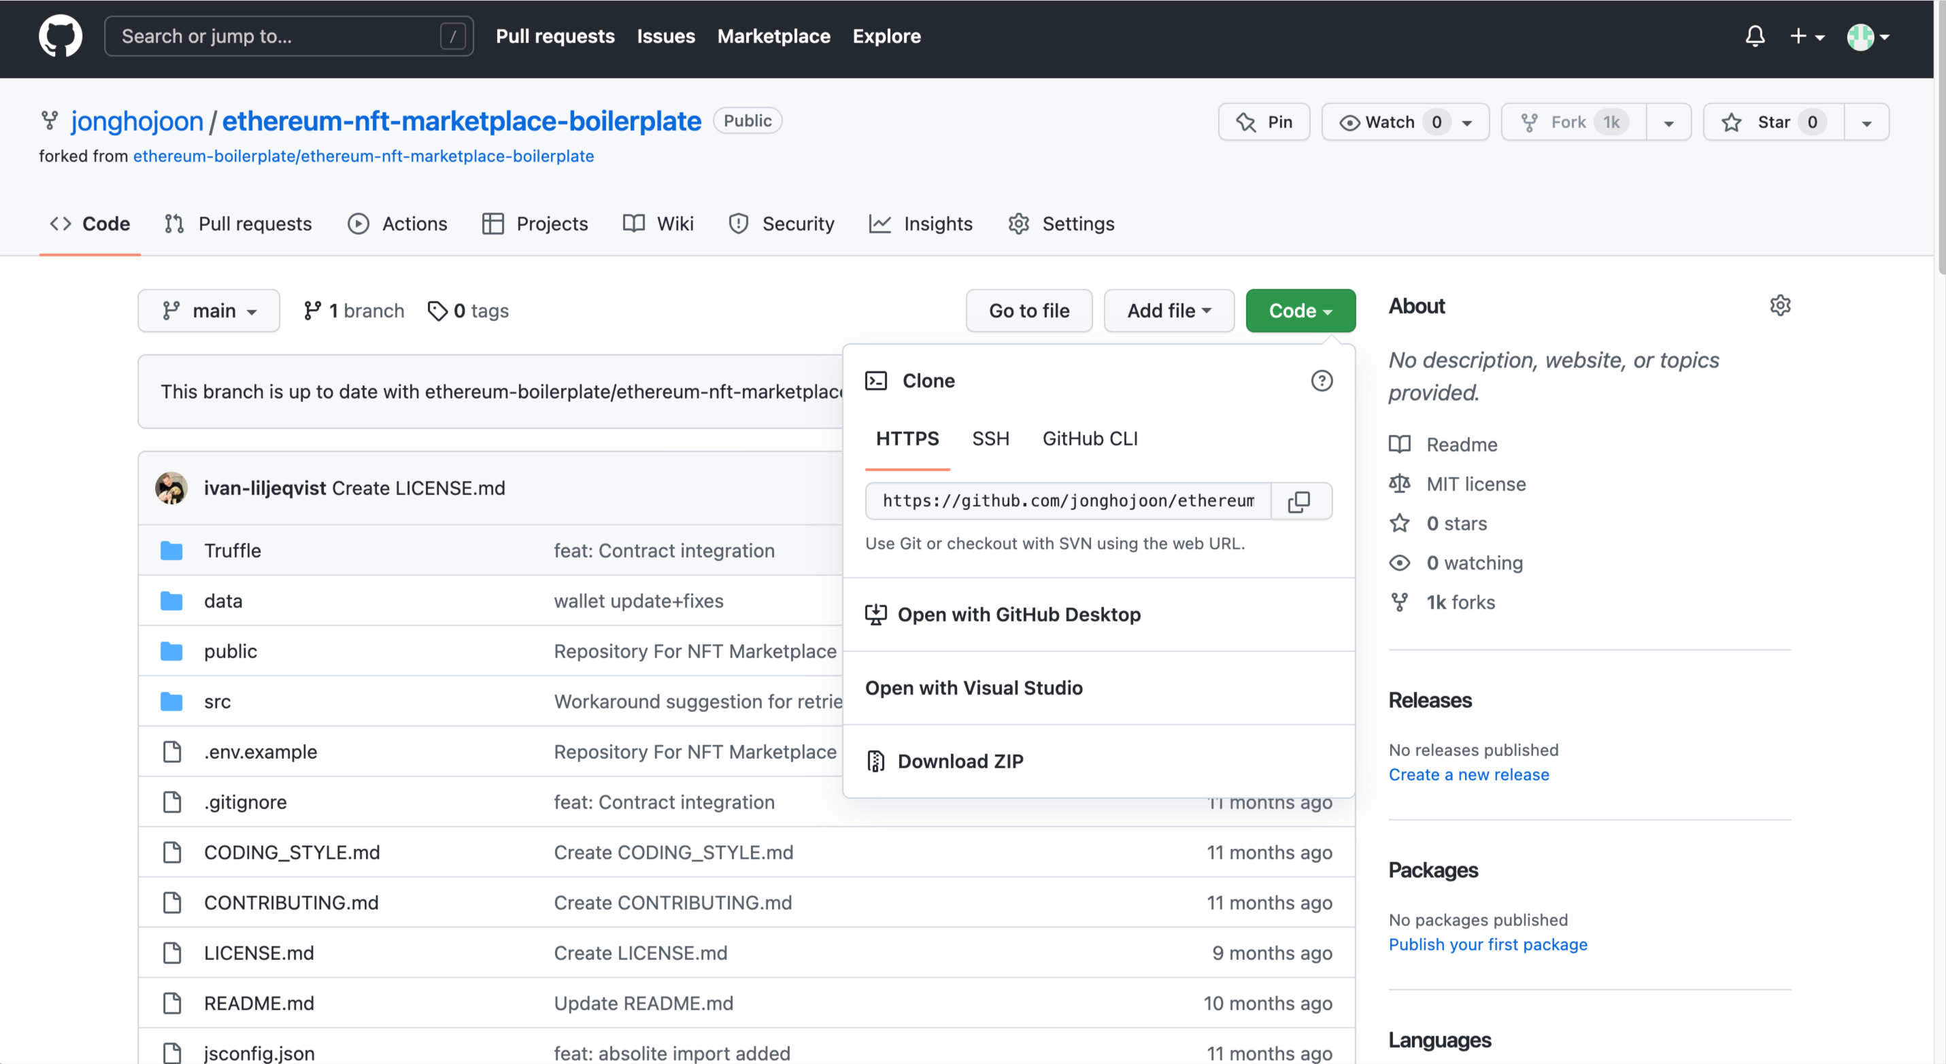

1. Let us follow the Quick Start - clone

Clone: Open your terminal. Copy and paste below command.

**git clone** [**https://github.com/ethereum-boilerplate/ethereum-nft-marketplace-boilerplate.git**](https://github.com/ethereum-boilerplate/ethereum-nft-marketplace-boilerplate.git)



If you cannot clone source code, you download and install Git.

<https://git-scm.com/downloads>

1. Let us follow the Quick Start – Install all dependencies

Go to the directory ethereum-nft-marketplace-boilerplate and yarn install

**cd ethereum-nft-marketplace-boilerplate**

**yarn install**

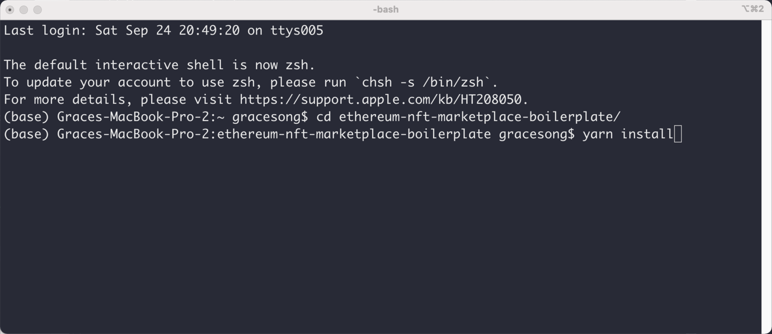

1. If you installed yarn under the directory successfully, you open the folder - Ethereum-NFT-MARKETPLACE-BOILERPLATE in Visual Studio Code.

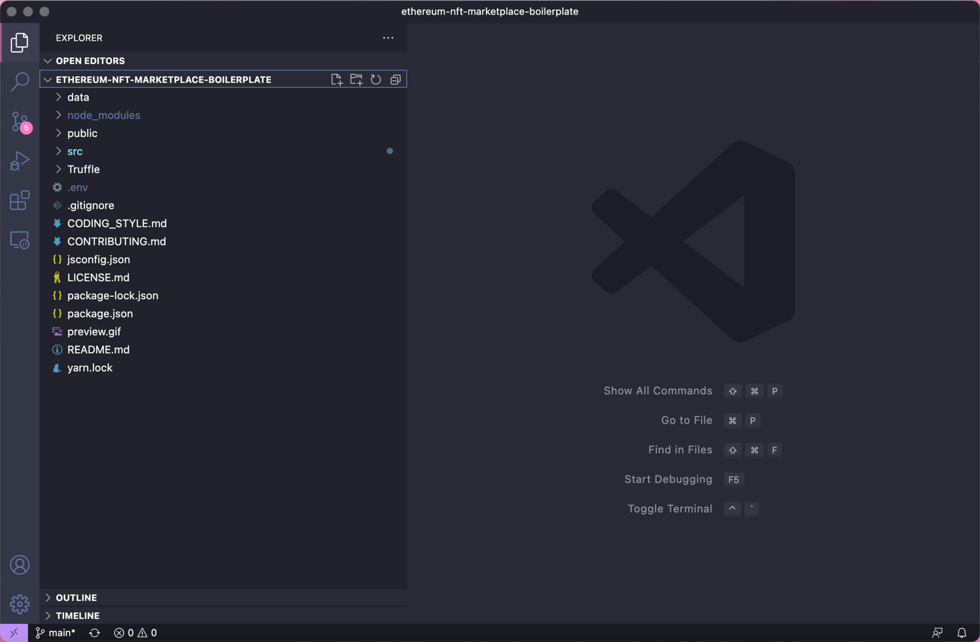

1. Rename .env.example to .env in the main folder and provide your appId and serverUrl from Moralis:

REACT_APP_MORALIS_APPLICATION_ID = xxxxxxxxxxxx

REACT_APP_MORALIS_SERVER_URL = <https://xxxxxx.grandmoralis.com:2053/server>

1. Login to moralis and set the servers up

Login: <https://moralis.io/>

Create new dapp: <https://admin.moralis.io/dapps>

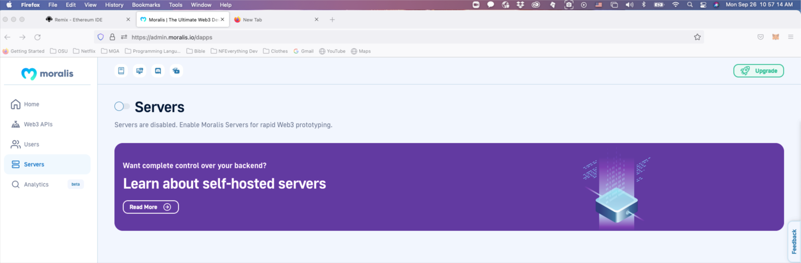

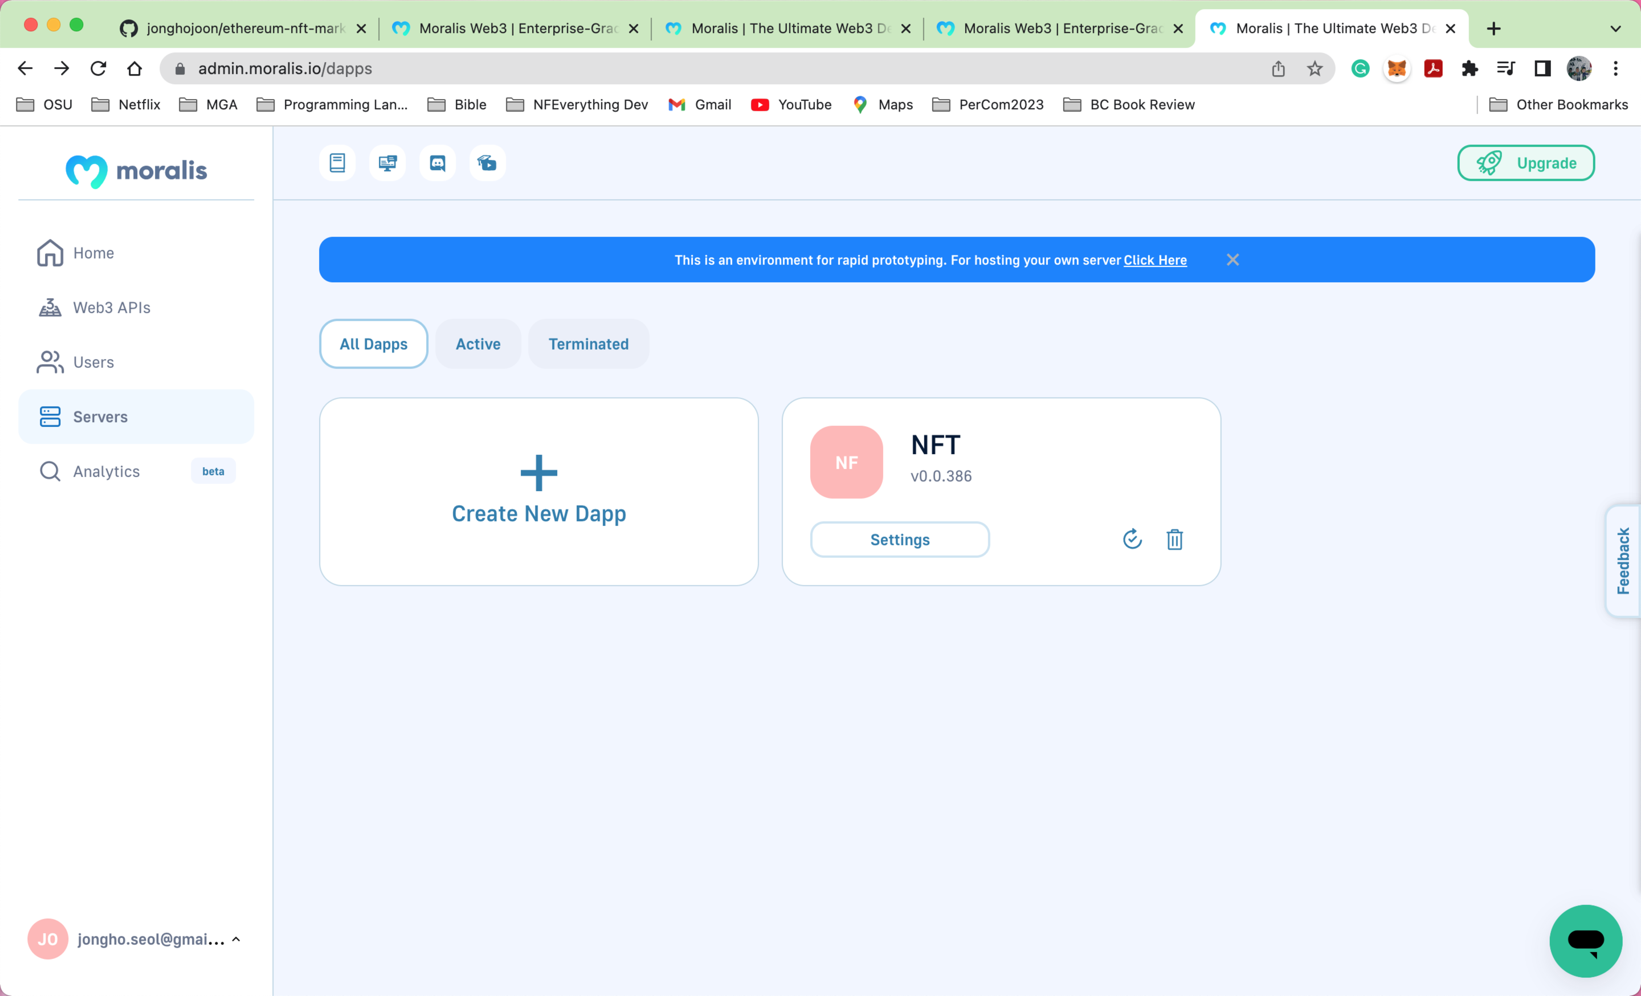

NFT created

1. Self-hosted servers: it will be documented separately Later (we need to go with self-hosted servers eventually)

<https://docs.moralis.io/docs/v1-server-self-hosting>



1. Find Dapp URL and Application ID of your Dapp in Servers

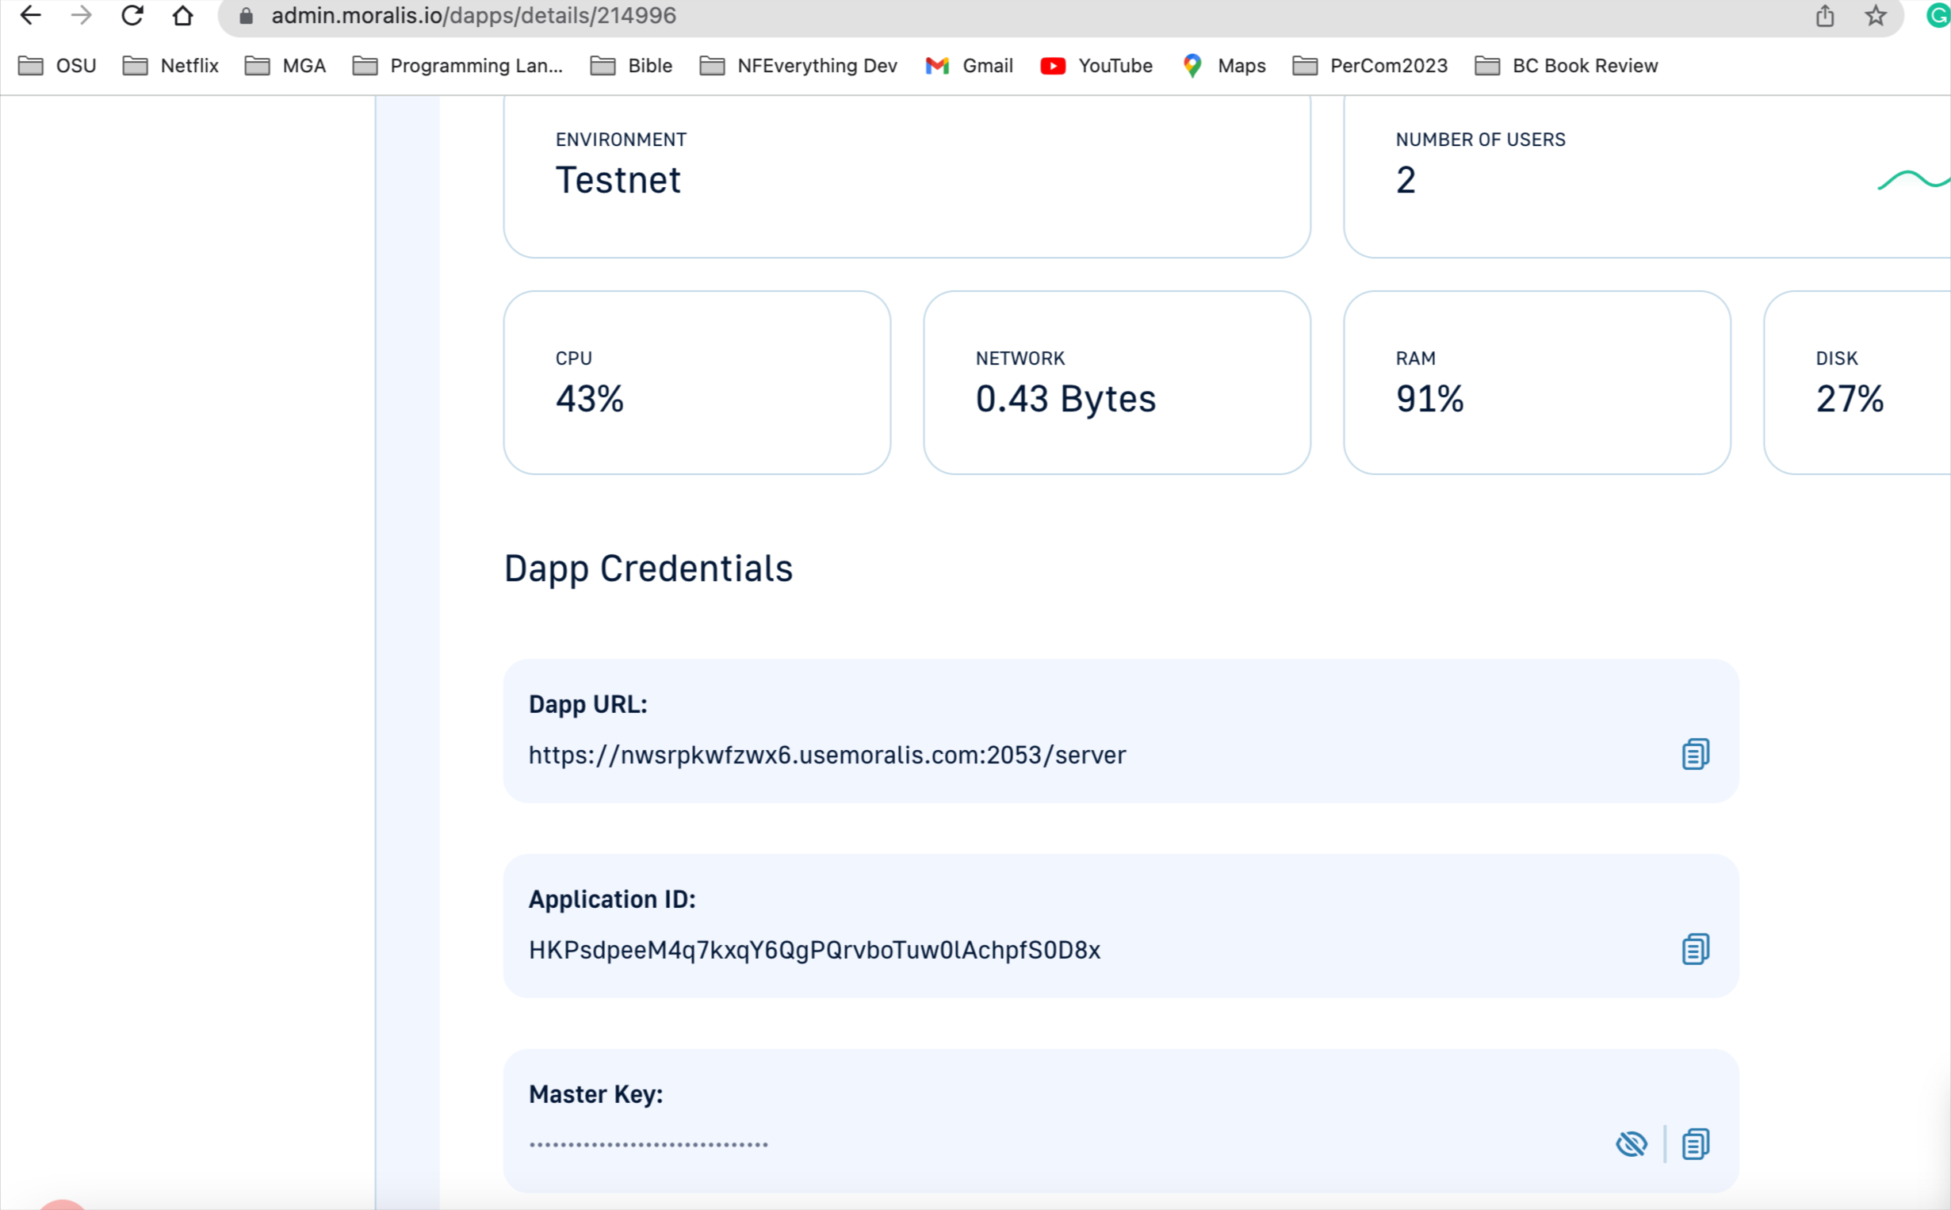

1. Rename .env.example to .env in the main folder and provide your appId and serverUrl from Moralis

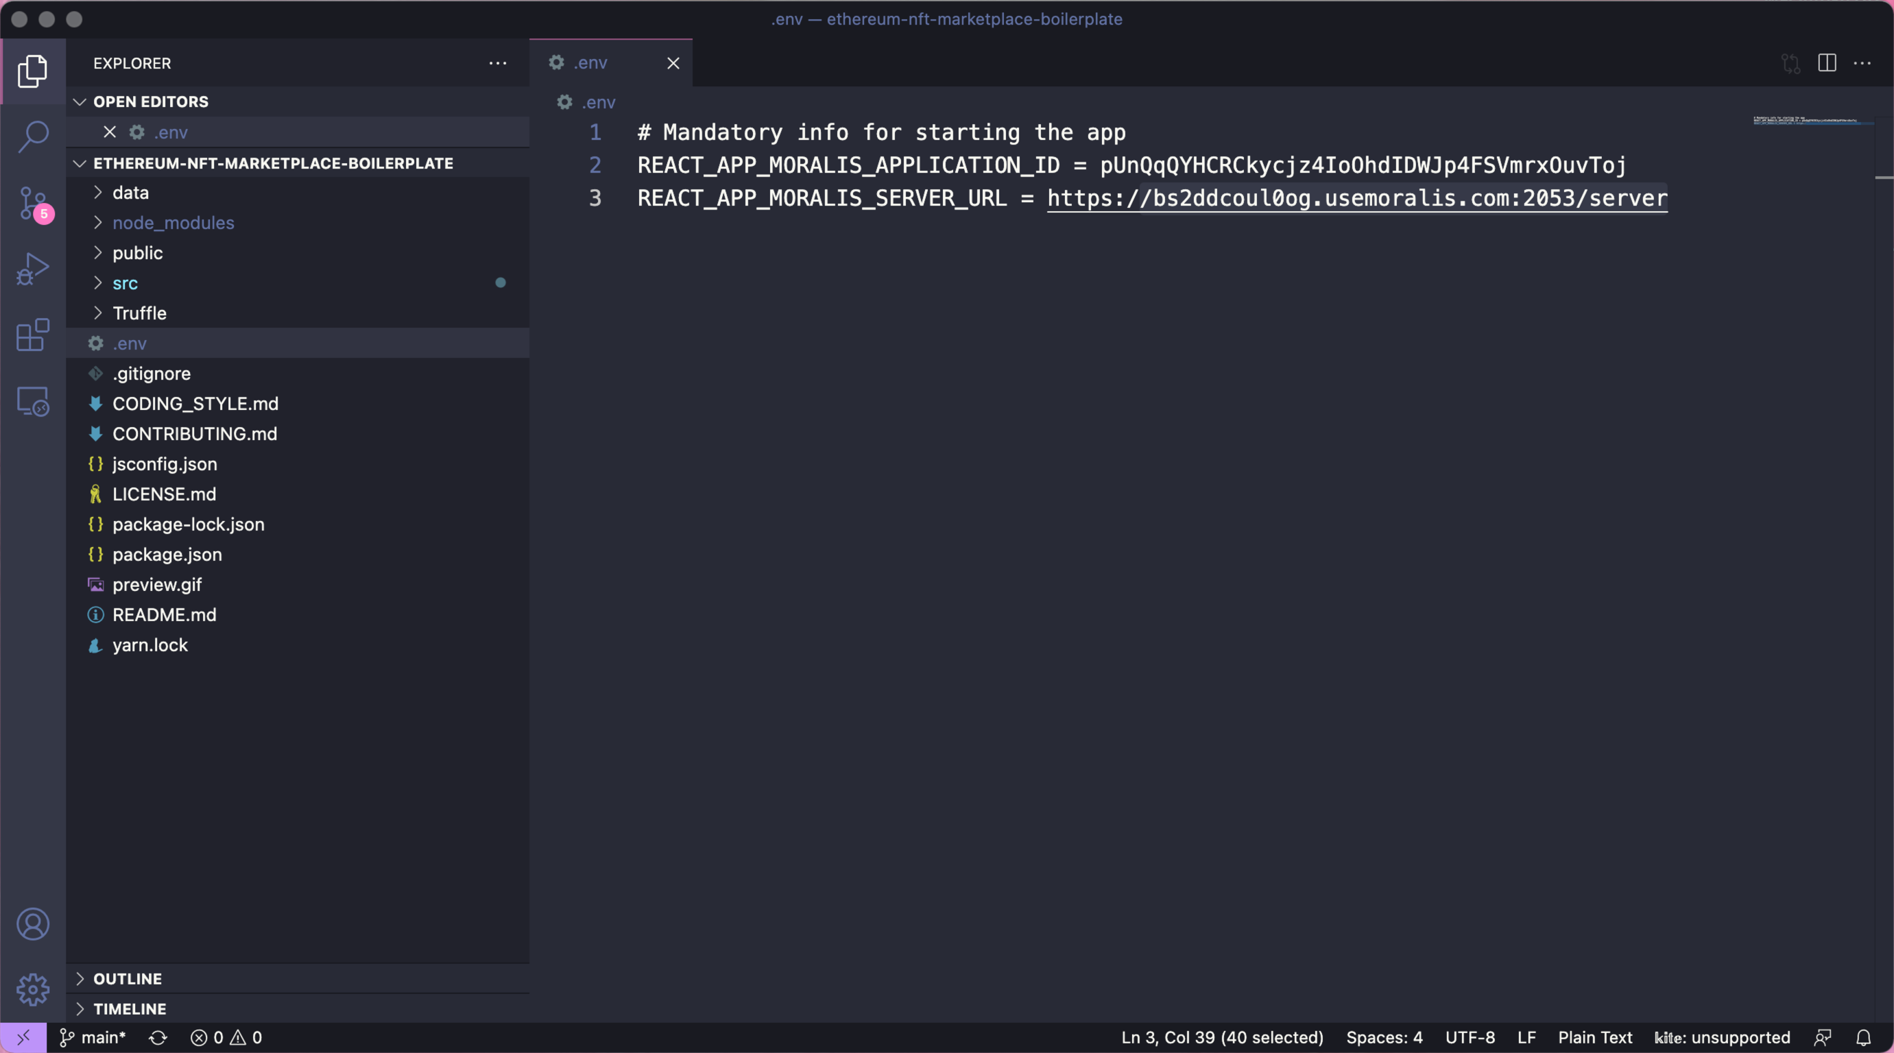

1. Compile & deploy marketplaceBoilerplate.sol in Remix online

Set the testnet as Ropsten which could be matched with Metamask account

Compile and deploy

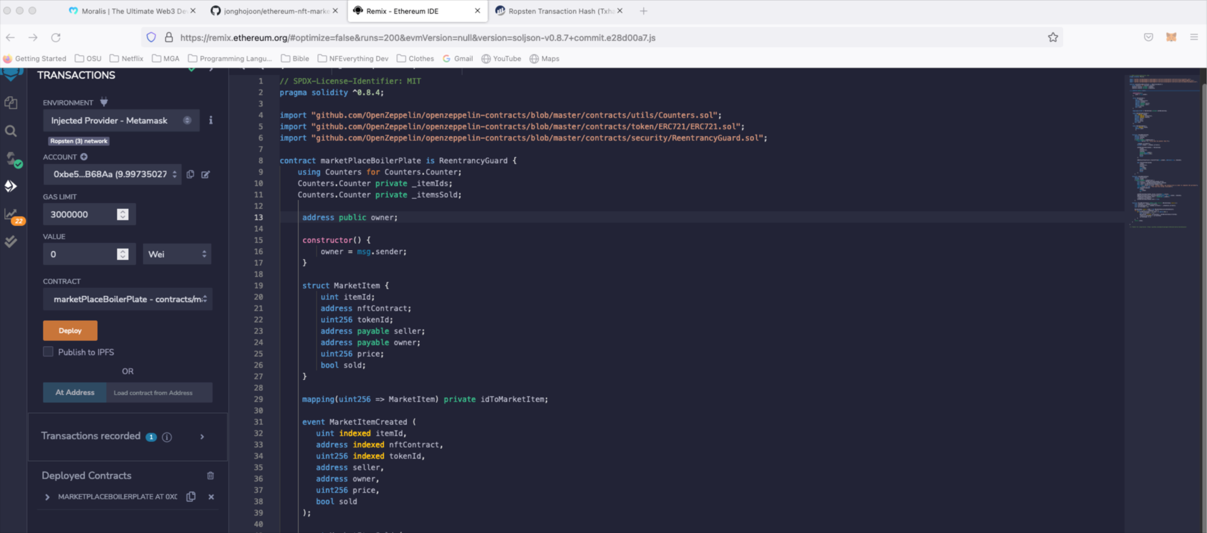

1. Check transaction details in Etherscan if necessary

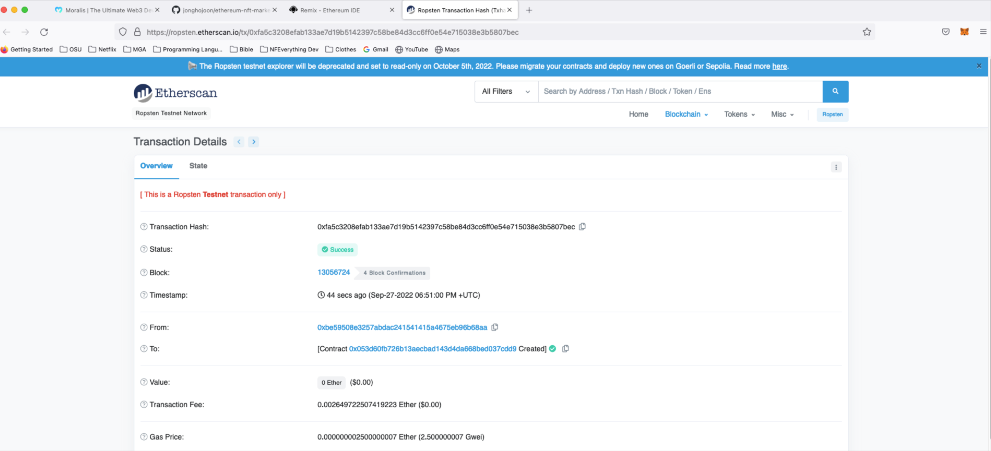

1. Find an ABI and copy it

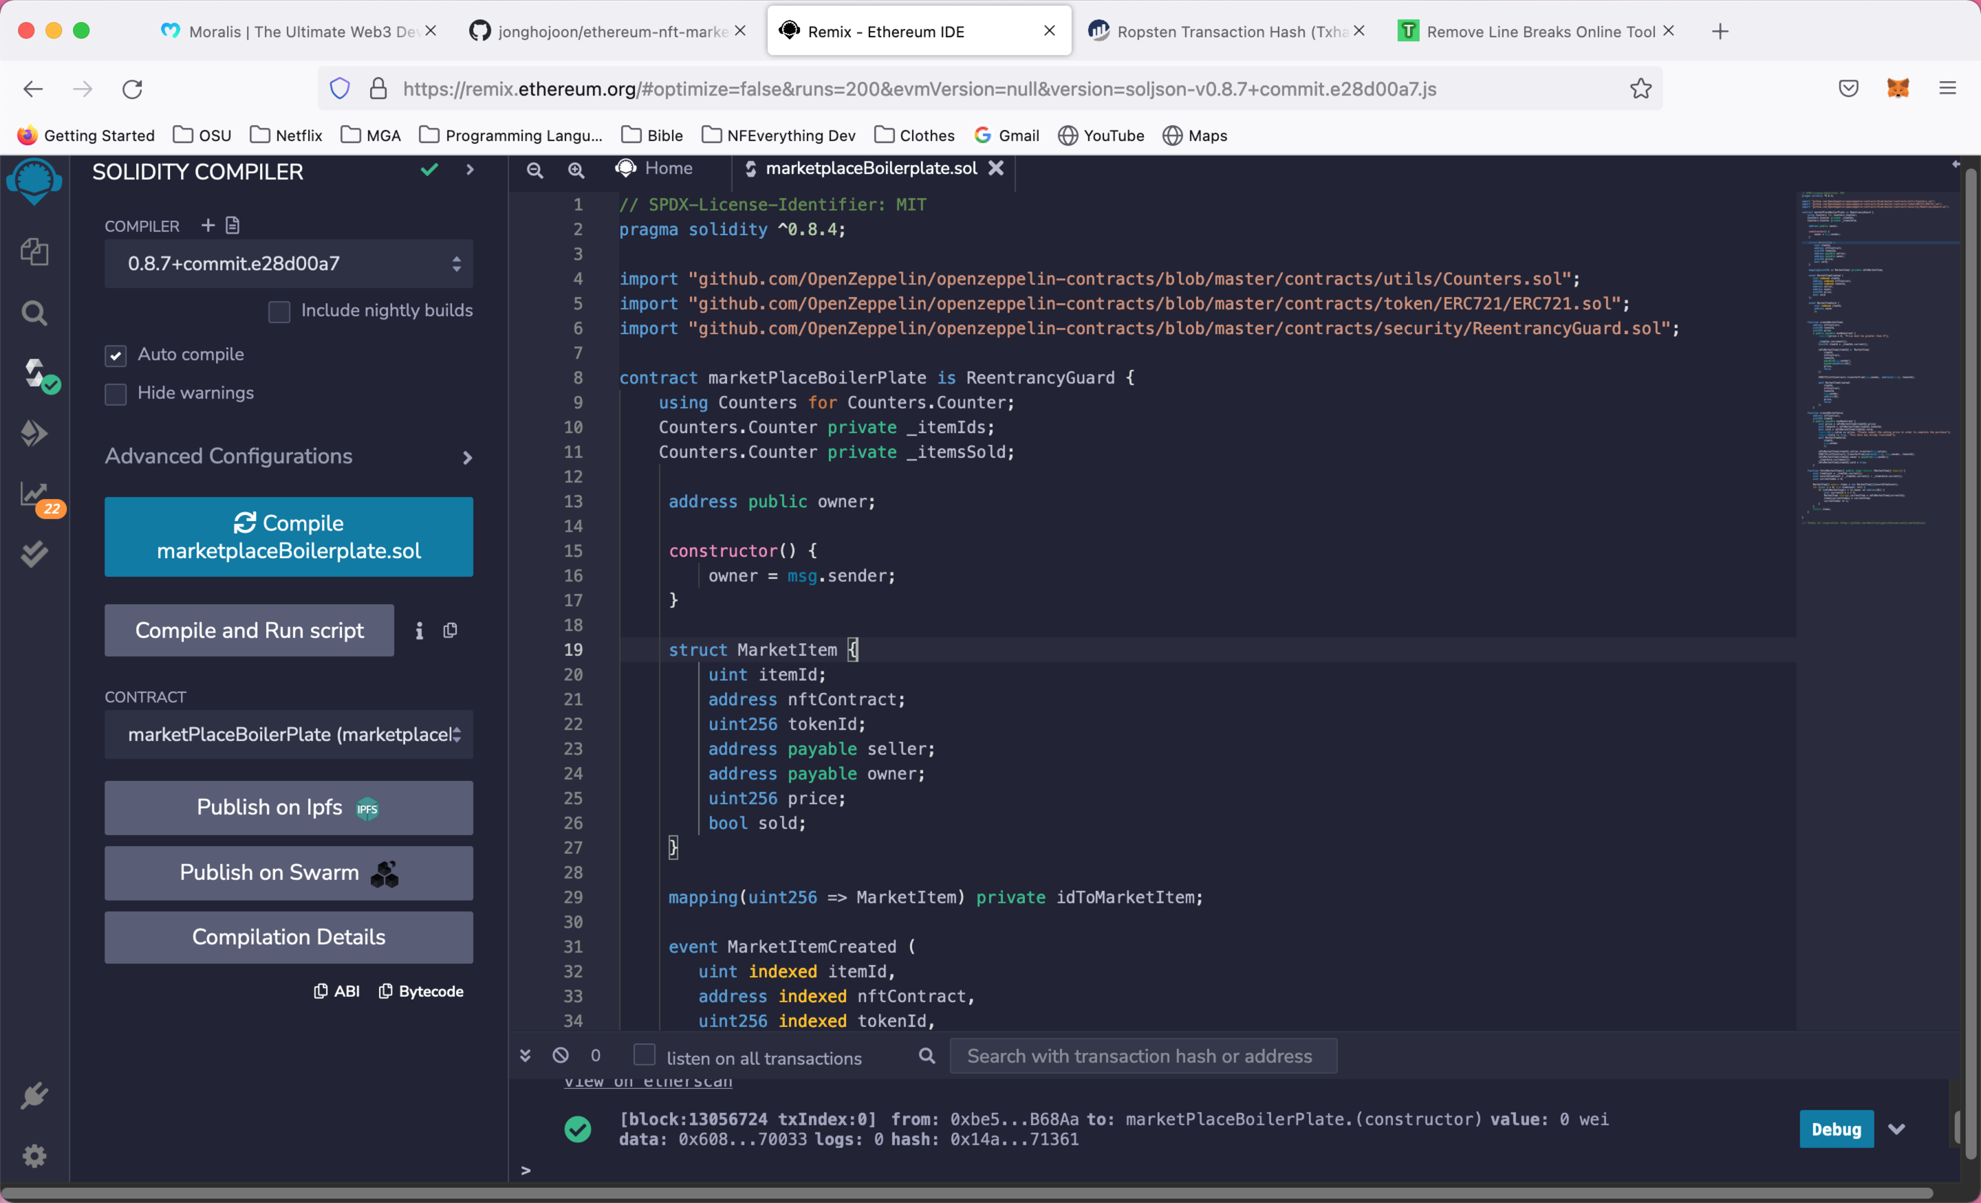

1. Remove line breaks and then copy new text without line breaks

<https://www.textfixer.com/tools/remove-line-breaks.php>

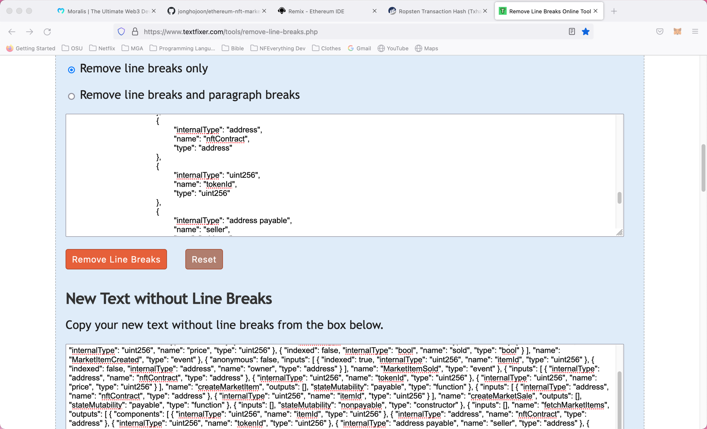

copy

1. Copy the paste ABI to setContractABI in MoralisDappProvider.js

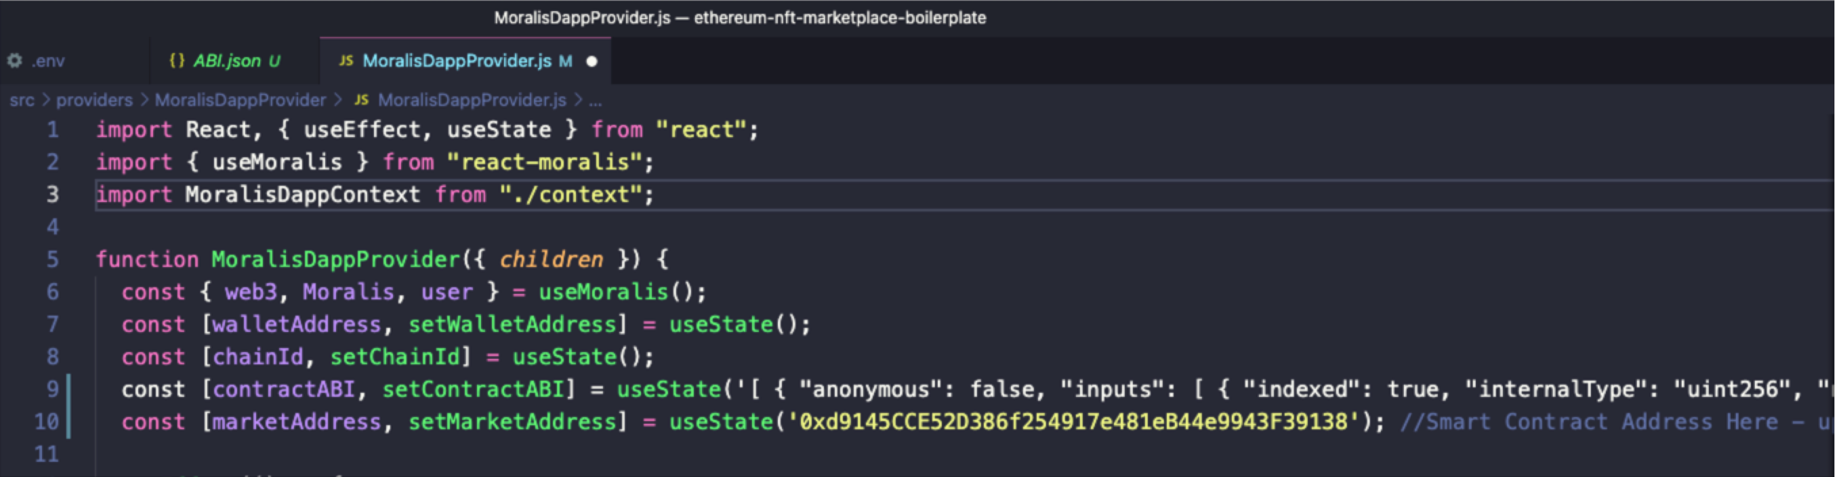

1. Copy and paste the smart contract address to setMarketAddress in MoralisDappProvider.js

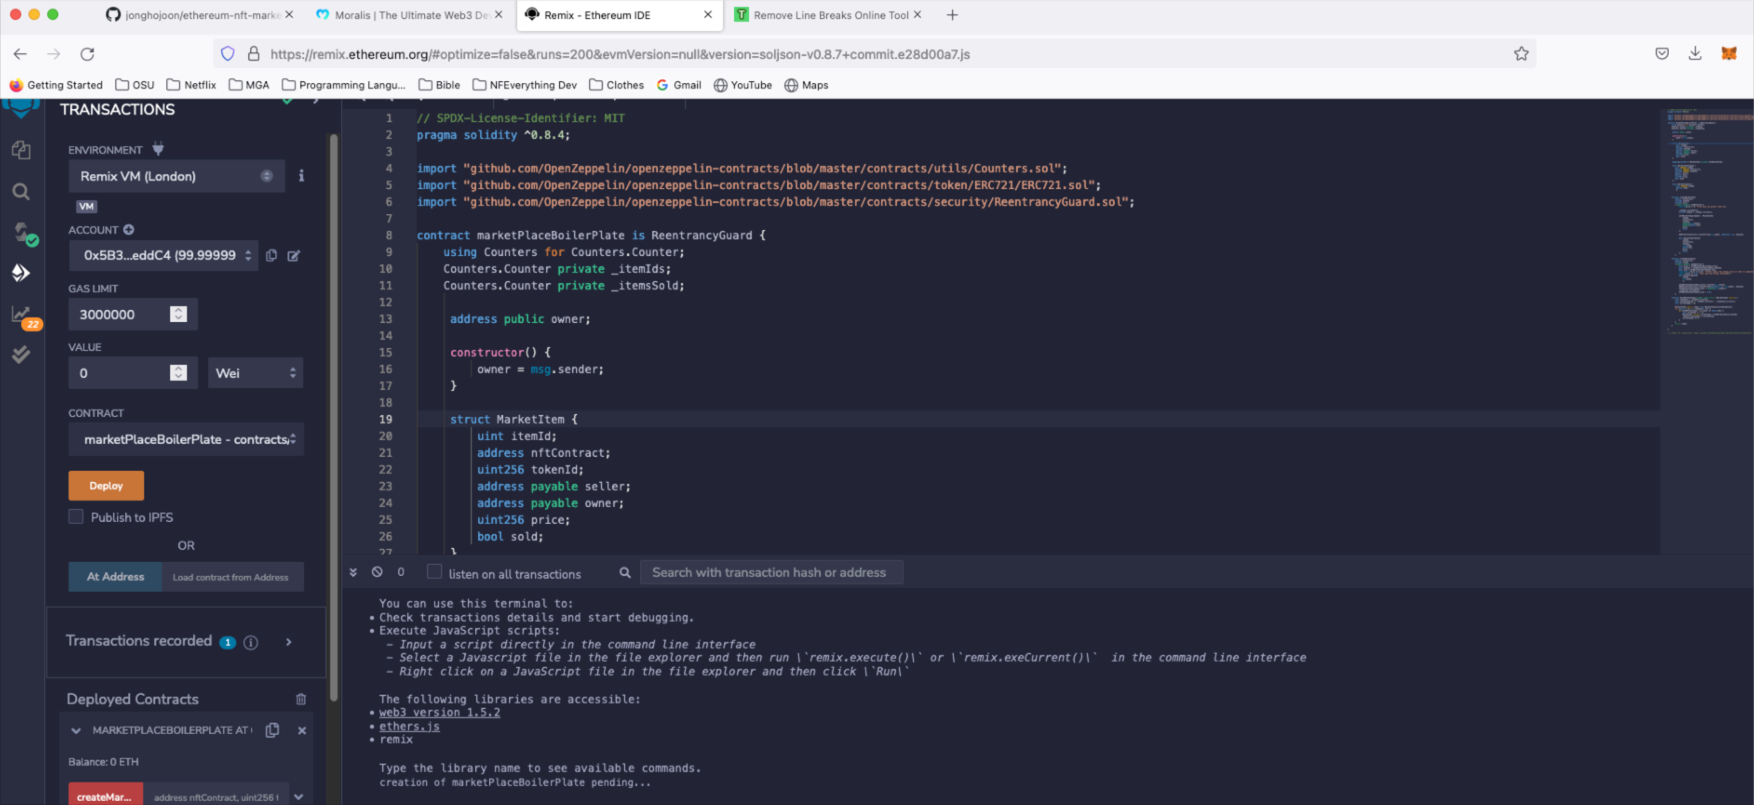

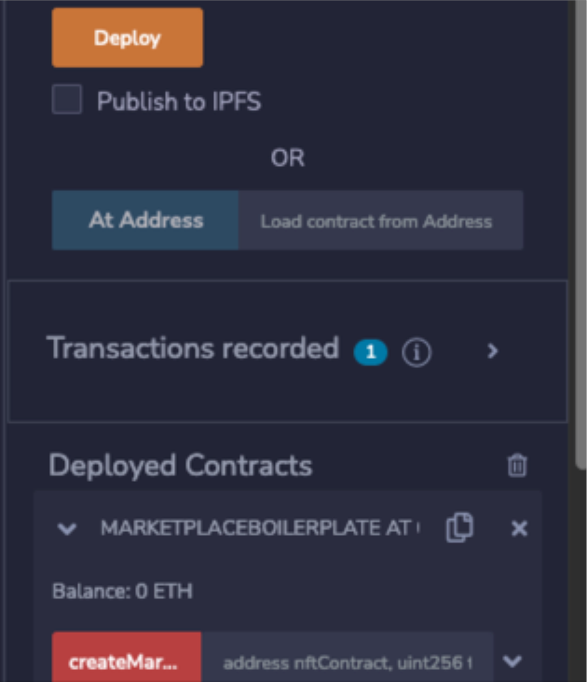

Copy smart contract address

copy

Paste smart contract address into setMarketAddress in MoralisDappProvider.js



1. Select Custom Event

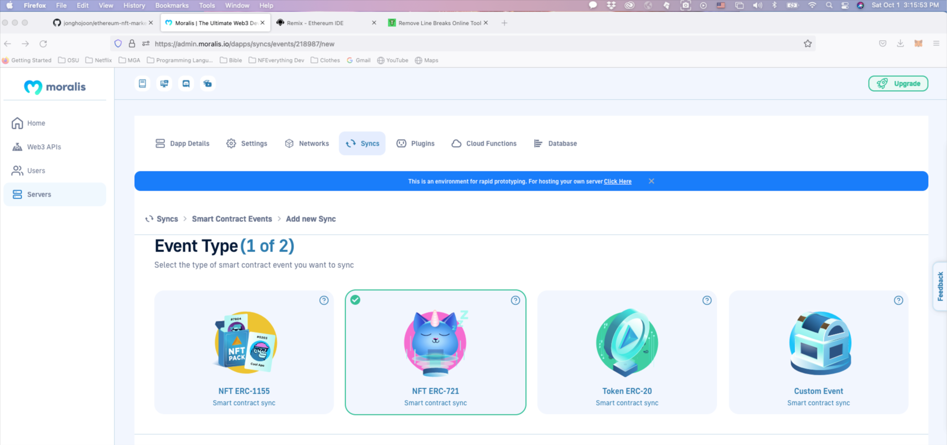

MarketItems Table created

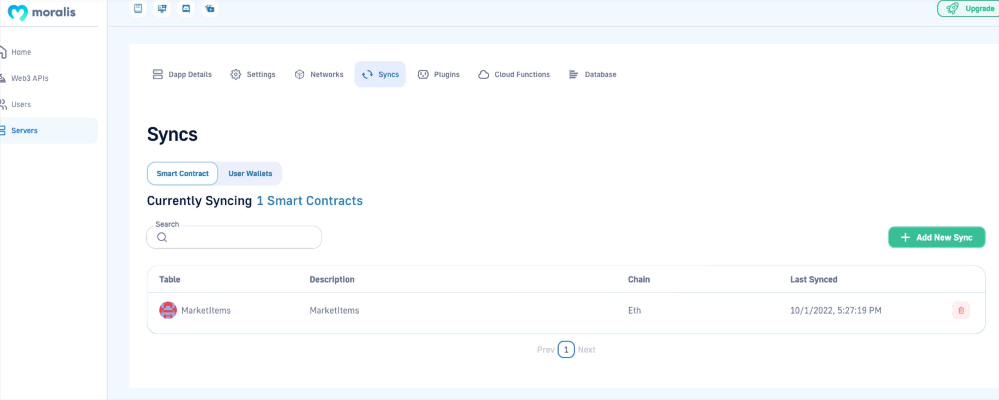

1. Servers is setup and ready to run.

Open a terminal and change directory to Ethereum-nft-marketplace-boilerplate

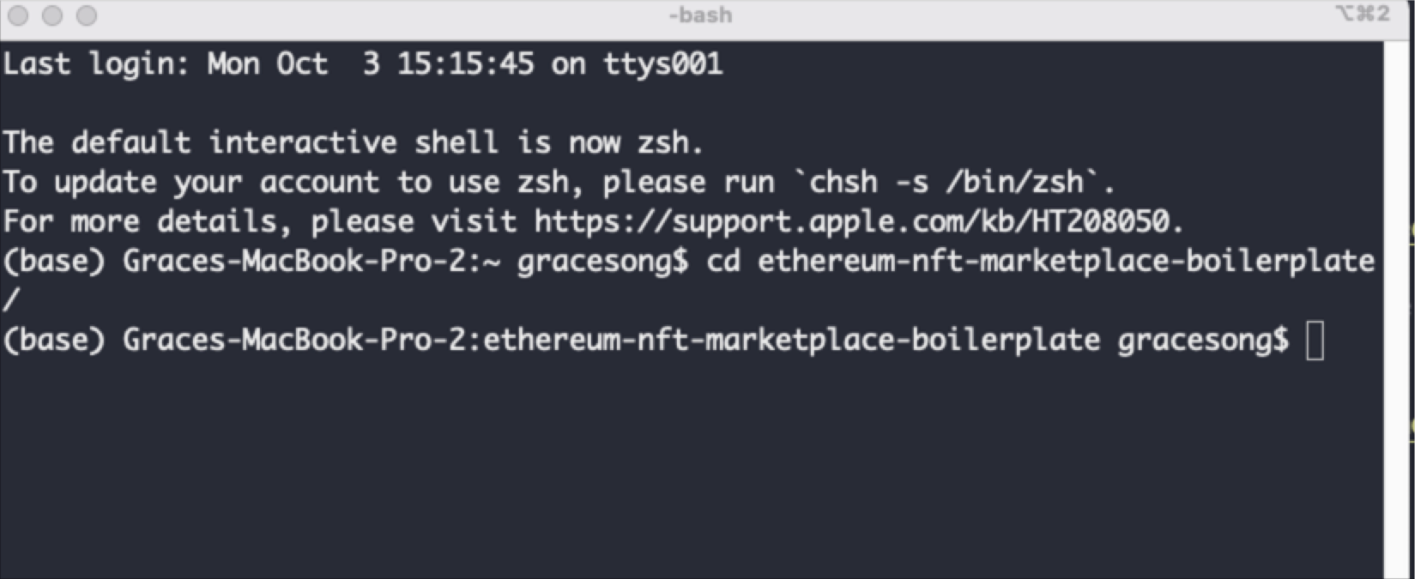

1. Run your app

yarn start

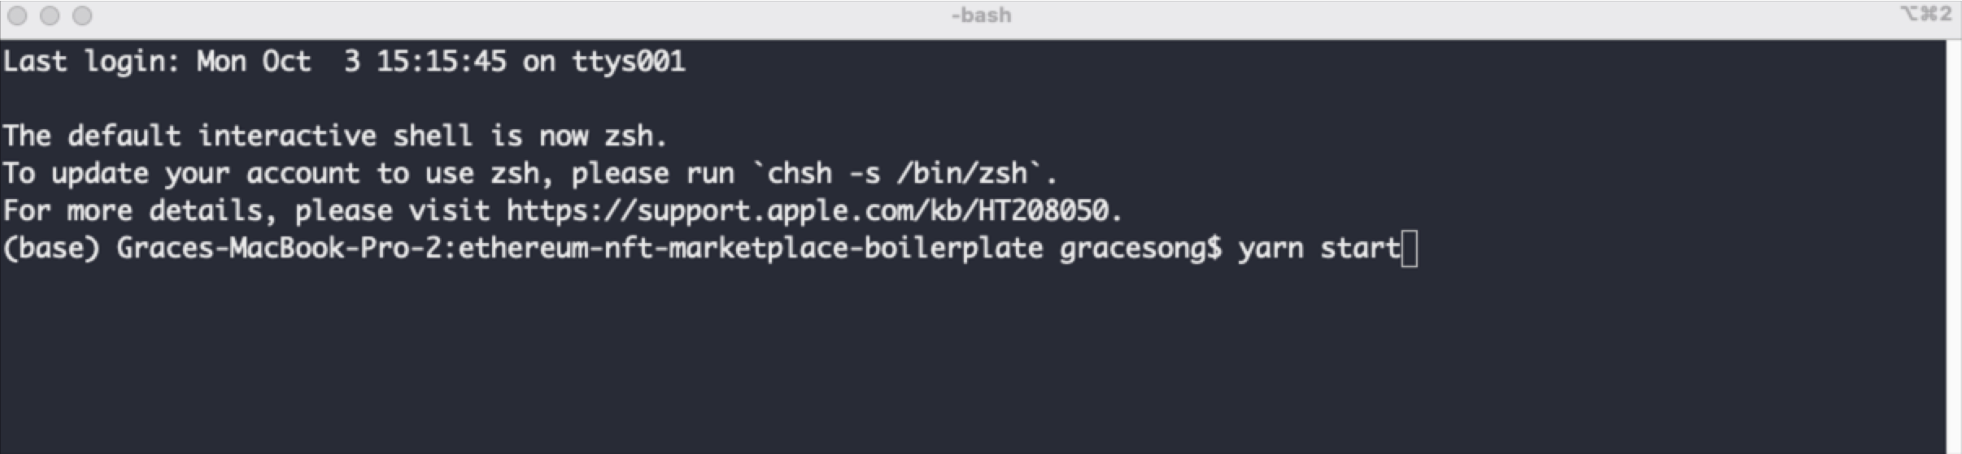

1. Localhost:3000/NFTMarketPlace runs

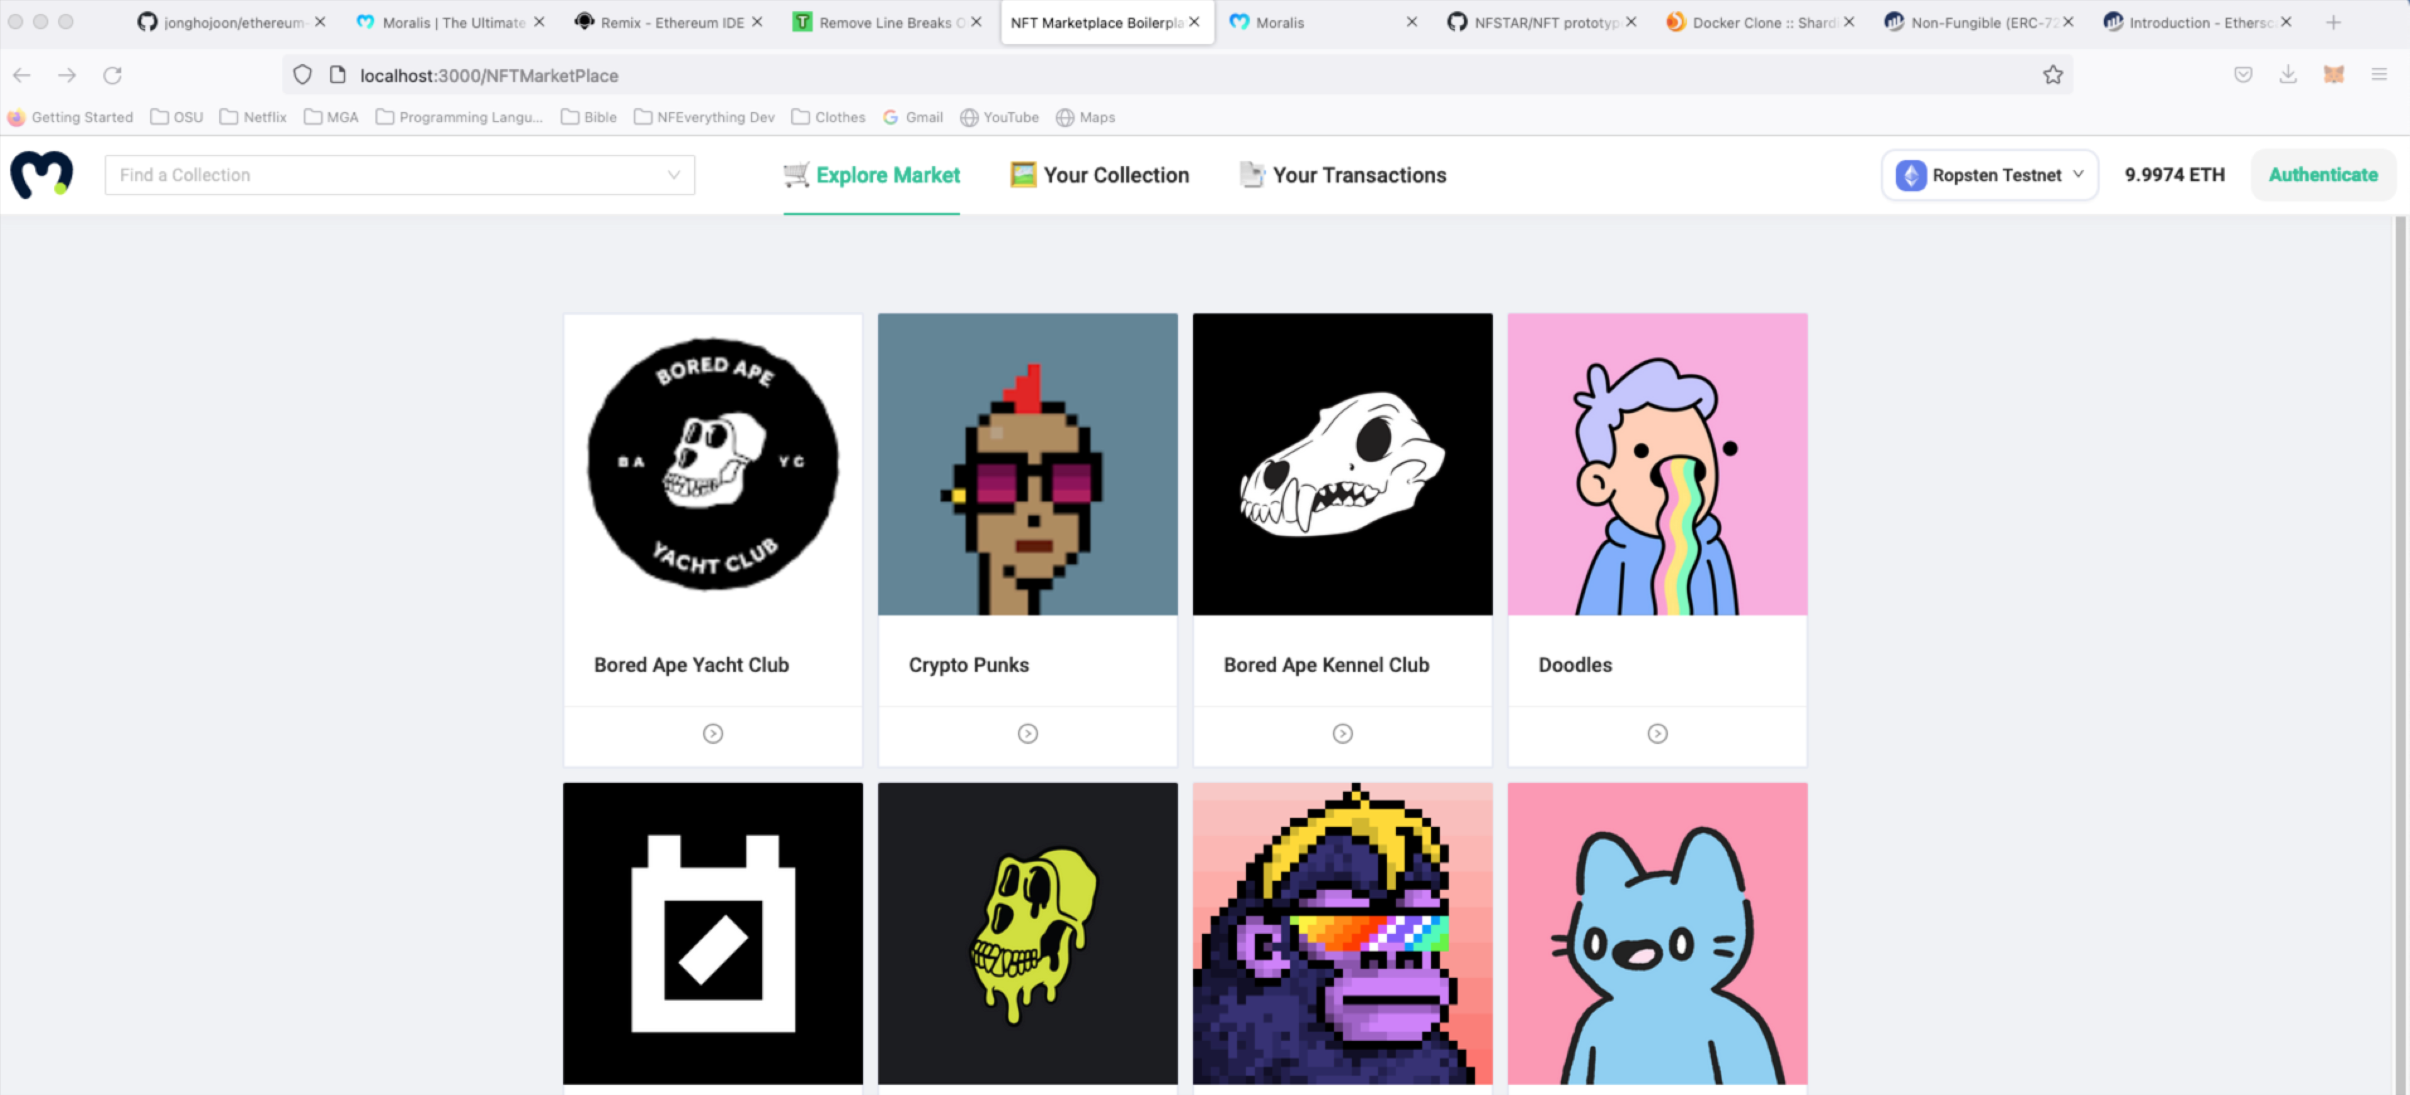

1. Check the Metamask connected with correct network

